Exp No. 11: Implementation of IoT-based Smart Agriculture using MATLAB

AIM:
To design and simulate an IoT-based smart agriculture system using MATLAB by
monitoring soil moisture levels, controlling water pump status (ON/OFF), and evaluating
irrigation efficiency for optimized water resource management.
Objective:
1. To monitor the Soil Moisture (%) level in agricultural fields using IoT-based sensing
simulation in MATLAB.
2. To control and display the Water Pump Status (ON/OFF) based on threshold soil
moisture conditions.
3. To evaluate the Irrigation Efficiency (%) by analyzing water usage effectiveness and
moisture maintenance level.
Procedure
1. Define soil moisture range (0–100%) and set an irrigation threshold value (e.g., 40%).
2. Generate or input soil moisture data to simulate field conditions.
3. Compare soil moisture with the threshold value to determine pump status (ON if low
moisture, OFF if sufficient moisture).
4. Simulate water pumping action based on control logic.
5. Calculate irrigation efficiency based on moisture improvement and water usage.
6. Display soil moisture level, pump status, and efficiency results.
7. Plot graphs to analyze soil moisture variation and irrigation performance.
8. Evaluate system behavior for smart agriculture decision-making.

Objective 1 Matlab Code and Output:
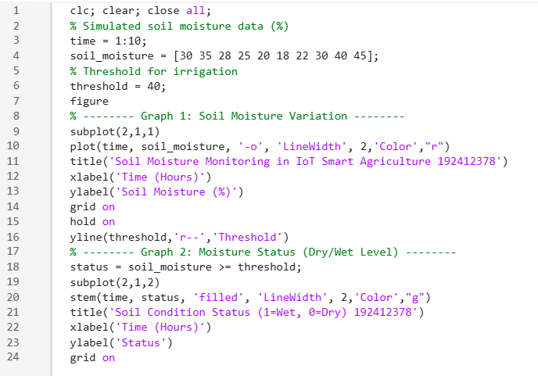
OUTPUT:
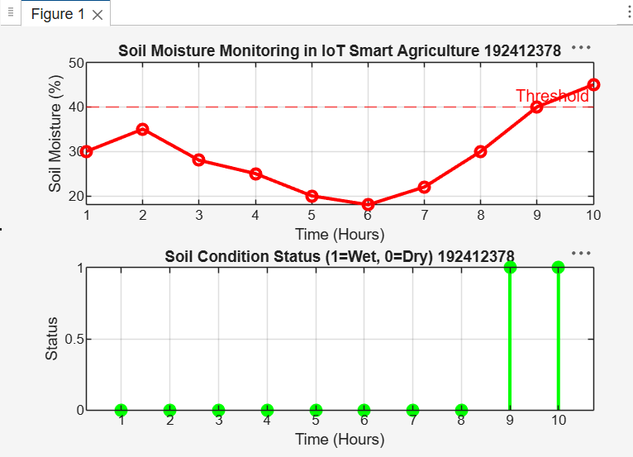
Soil moisture levels vary over time, showing fluctuations in field water content.
The threshold line helps identify dry and wet conditions for smart irrigation decisions.

Objective 2 Matlab Code and Output:
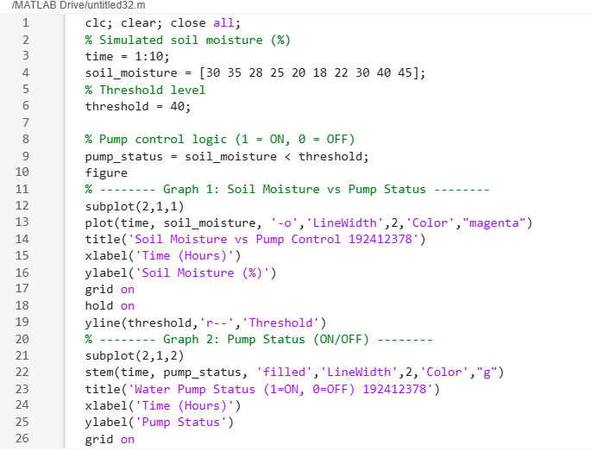
OUTPUT:
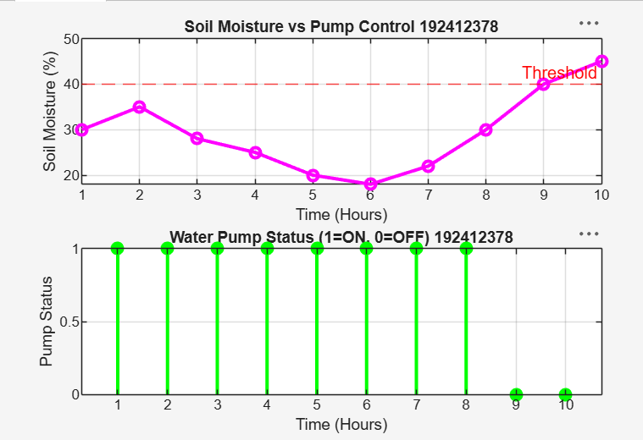

The pump turns ON automatically when soil moisture drops below the threshold level.
When moisture is sufficient, the pump remains OFF, ensuring efficient water usage and smart
irrigation control.
Objective 3 Matlab Code and Output:
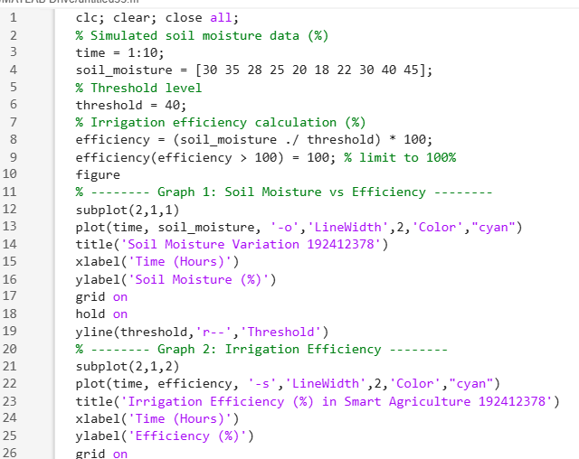
OUTPUT:
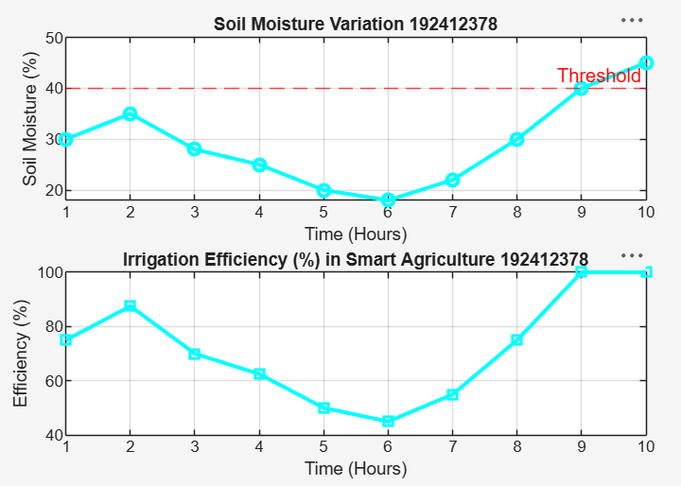
Irrigation efficiency increases when soil moisture approaches the optimal threshold level.
The system ensures better water utilization by maintaining soil moisture within the desired range using smart control.

Result:
1. The soil moisture levels were successfully monitored using MATLAB simulation,
showing variation over time and identifying dry and wet conditions based on threshold
values.
2. The water pump control system was effectively implemented, where the pump
automatically switched ON when soil moisture dropped below the threshold and
remained OFF when moisture was sufficient.
3. The irrigation efficiency was successfully calculated and analyzed, showing that the
system optimizes water usage by maintaining soil moisture close to the desired level.

